**CS 6200: Information Retrieval**

**Final Project Report**

**Team Members: Meet Nandu, Praguna Singh, Yash Kothari, Sanyam Harne**

The task –

The digital space gives us an opportunity to explore and experiment without any limitations – literally anything we dream of can manifest right in front of us with just a few clicks. GIFs are one way we’re pushing these limits, altering the way we communicate with one another in cyberspace.

Even if you can’t define the word “GIF,” you’ve definitely seen one before. They helped define the early internet, and they’re more popular now than ever before. But what exactly is a GIF, and how do you use them? In its simplest form, a GIF (pronounced “gif” or “jiff”) is just an image file. Like the JPEG or PNG file formats, the GIF format can be used to make still images. But the GIF format has a special feature—it can also be used to create animated images like the one below.



GIFs really started infiltrating pop culture when netizens began slicing up iconic moments from TV shows and films and sharing it with their friends. It quickly gained popularity as people can relate to that singular moment and sharing it with their friends is like sharing an inside joke. Just like emoticons, it has slowly evolved into a way to express yourself on the internet.

With the rise in popularity, companies like GIPHY and Tenor are taking advantage of them while using a searchable database like Google. GIPHY is one of the largest search databases and search engines for GIFs. And the second largest after Google. It serves over 10 billion GIFs a day through social media and messaging apps. Another popular GIF search engine is Tenor, acquired by Google in March of 2018.

The main task of this project would be to create a search engine that would retrieve GIFs with queries on description of the GIF, dialogues, captions, and so on. A user would type in a query and would expect a GIF related to that query. That is what the search engine would aim to do.

**Proposed Modeling Approach** –

We have a corpus of around 129000 GIFs with their descriptive tags that can be used for the search engine. We will use the Vector Space Model approach for the query search as follows:

* **Stopping**: We plan to first remove all the stop words from the corpus. Stop words are the most frequently used words in a language. These words being very frequently used do not provide any significant context to the description of a GIF. Thus, we can ignore them while creating tokens for the GIFs. Hence, we will remove all the stop words from the set of GIF descriptions first.
* Next, we will remove all the punctuations from the descriptions as they do not provide any information about the context of the gifs. Hence, they may cause the same words in different descriptions to be considered different. For example, two descriptions having “Dwayne Johnson” and “Dwayne, Johnson” tags respectively might be similar, and may both be the result of the query but due to the punctuation they might provide incorrect results and only one of these might show up based on which is closer to the provided query.
* **Stemming:** Next, we will do stemming on the descriptive tags of the GIFs to get the root words of different forms of the same words, for example having and have, etc. This will allow us to remove redundant tags which might have the same meaning and provide a similar context to the descriptions of GIFs.
* **Tokenize**: Next, we will tokenize the descriptions and get all the tokens that provide meaningful context to the GIFs and can be used for our search engine.
* **Tfidf**: Next, we will calculate the tfidf of all the terms/tokens in the descriptions and store it in the dictionary as the value of the tokens which can be further used for our modelling approach.
* **Vectorizing Documents**: Next, we will create a vector representation of each description of GIF and store it for query search using cosine similarity. The vector of the descriptions seen in a tabular fashion will look like the following figure:

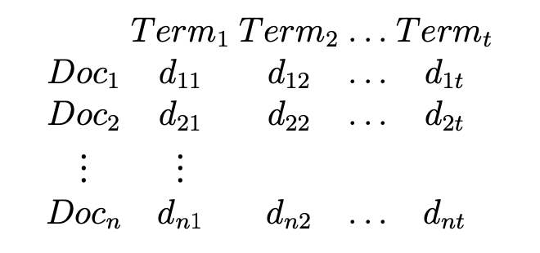

Figure 1: Term-Document matrix for a collection of 4 documents

As seen in figure 1, we will create a dictionary of the vectors of each description which will have tfidf values of the tokens present in the document as their values and 0 values for tokens absent in the documents. Each document token will look like figure 2.

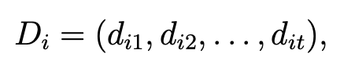

Figure 2: Vector for each GIF description

* **Query Processing:** We will take the query from the user and remove any punctuations from the query and implement stemming as before. This will provide us with an optimized query for the search.
* **Vectorizing Query:** Next, we will vectorize the query like the descriptions of GIFs. Hence, creating a vector representation of the query as well.

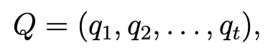

Figure 3: Vector for Query

* **Cosine Similarity**: Next, we will find out the cosine similarity between the query and each GIF description, to find which GIF matches closely to the query. Then we will sort the cosine similarities for the query with each GIF in a descending order and the top 10 results will be shown to the user as query search results. We will use the following formula for the getting the query similarity:

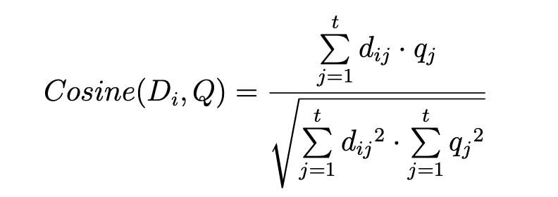

Figure 4: Cosine Similarity between Query and GIFs

**In General, what do Queries Look Like?**

The proposed search engine will expect queries like:

* Man woman
* Dog cat
* Happy man
* Dancing woman
* Man woman dancing

**Query Results –**

The search engine will provide with a list of 10 GIFs that match closely or are potential search results for the query. These will be sorted in the order of how likely the GIF is the result the user is looking for.

For example, if the query is: “Northeastern University” the results will be GIFs which are related to Northeastern University. If the dataset contains very few GIFs related to NEU, the rest of the GIFs might relate to weather in the Northeastern states or the students in a university. The possible results for the above query are:

 

 

We will be showing the top 10 GIFs that we get after running the model. The above results are just a sample of what we expect the results to look like.

**Evaluation Metrics –**

We will be using the following metrics to decide the correctness of our proposed search engine:

* **Precision**: This will show us how relevant are the search engine’s retrieved results. It is given as a fraction of the number of relevant documents retrieved by the number of retrieved documents.

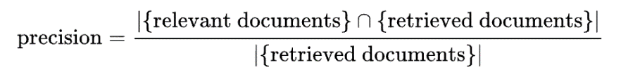

Figure 5: Precision

* **Recall**: This will show us how good is the search engine in retrieving the relevant results. It is given as a fraction of the number of relevant documents retrieved by the total number of all the relevant documents. It is often called the sensitivity of the search engine.

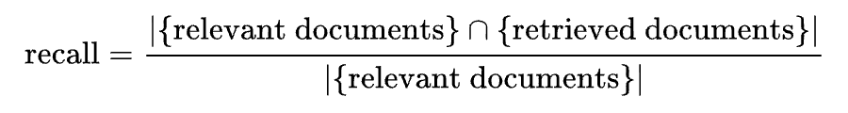

Figure 6: Recall

* **Weighted precision**:We also plan to use our own evaluation metric based on how satisfying the retrieved results are. We will first rate the results as completely satisfying (2), partially satisfying (1) or unsatisfactory (0). Sum these weights for each retrieved result and then divide it by the 3*(Number of retrieved documents.)

$$Weighted Precision=\frac{\sum{(Rated weight of each retrieved document)}}{3*(retrieved document)}$$